**Arrow Trap Package Doc**

Arrow Trap package consist with, two usable methods of arrow traps. When Player entering to the trap, arrows going to fire and time-based firing arrows as in arrows going to fire in every 3seconds.

*Arrow Trap Script*

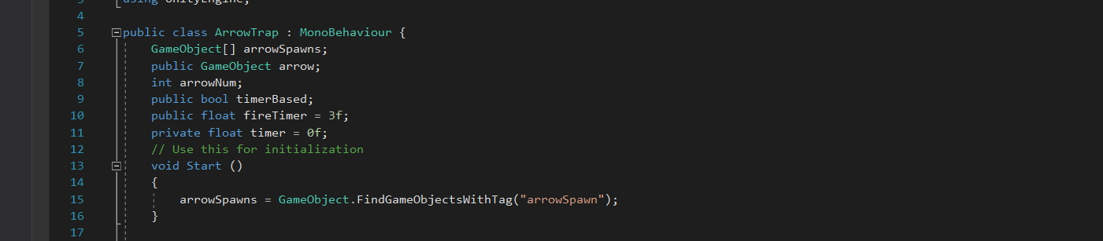

First referencing arrow spawning positions, referencing the arrow game object, putting a int number on number of arrows going to fire, adding a bool so can activate or deactivate time based arrow shooting, Adding a number, fire arrows every 3 seconds.

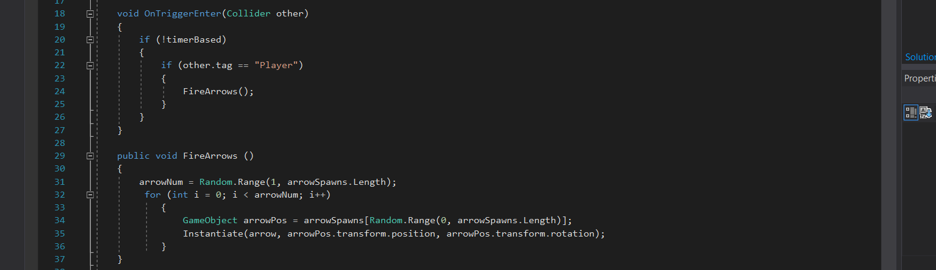

When Player enters to the collider, fire arrows. The object should be tagged as “Player”. Arrows not going to fire if any other tagged object gets into the collider.

Assigning the number of arrows, fire arrows in random number. Sometime it will be 3 arrows, 2 arrows or a single arrow firing from the arrow trap.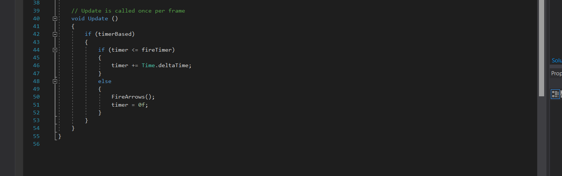

Under the “update” methods, the timer is assigned to the trap.